**TABLE OF CONTENTS**

* **OBJECTIVE**
* **INSTALLATION OF DOCKER AND PYTHON**
* **CUSTOMIZATION OF IMAGE**
* **Curl**
* **Git**
* **Python3 and pip**
* **BUILDING DOCKER IMAGE**
* **RUNNING PYTHON APPLICATION**
* **EXPOSING THE CONTAINER TO THE HOST SYSTEM**
* **CHALLENGES AND SOLUTION**
* **CONCLUSION**

**Objective:**

Learn the fundamentals of Docker by creating and working with Docker images and containers. This project will help you understand the process of containerization, image customization, and application deployment using Docker.

**Assignment: Docker Basics Project**

* **TASK 1: INSTALLATION OF DOCKER AND PYTHON**

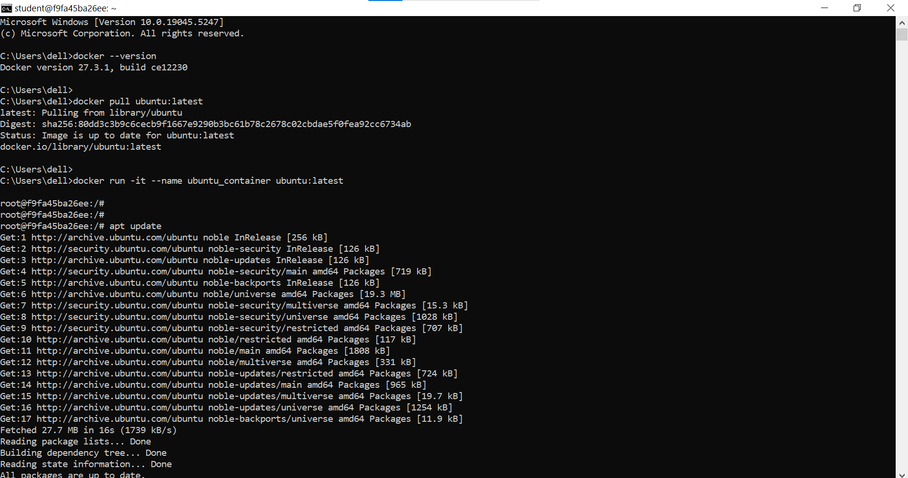

* **TASK 2: CUSTOMIZATION OF IMAGE**
* **Curl**
* **Git**
* **Python3 and pip**

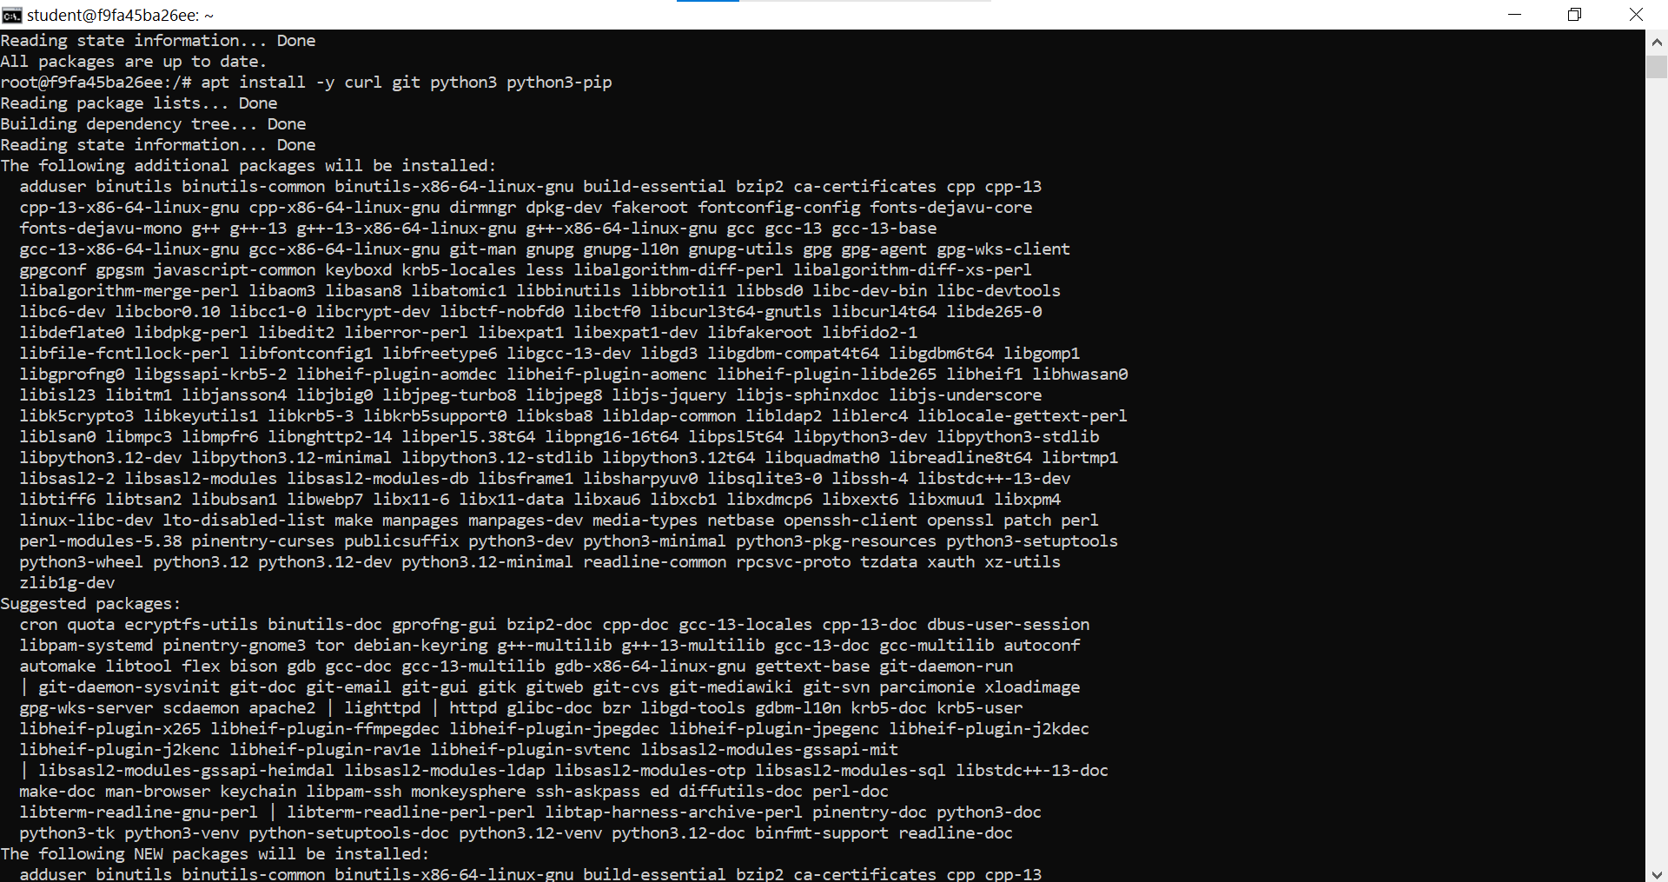

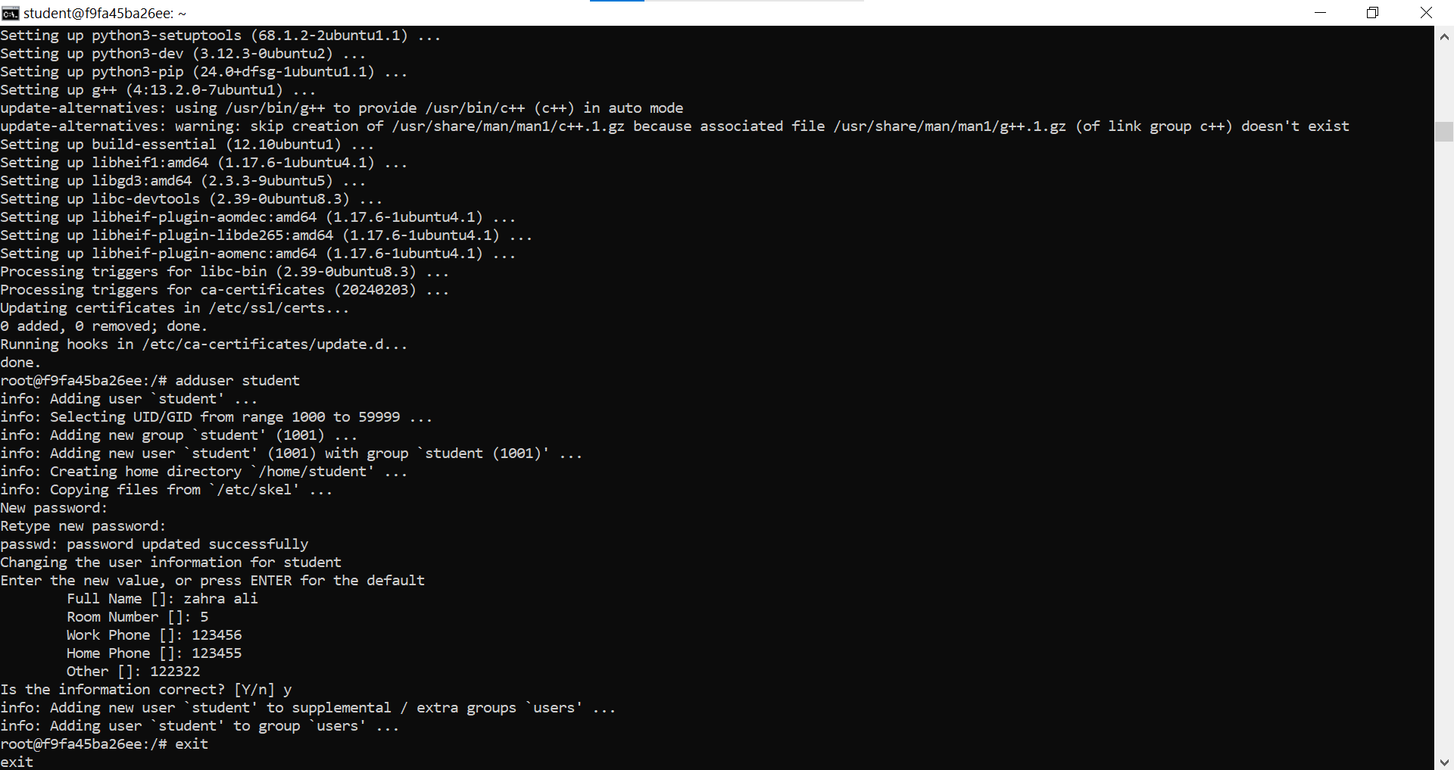

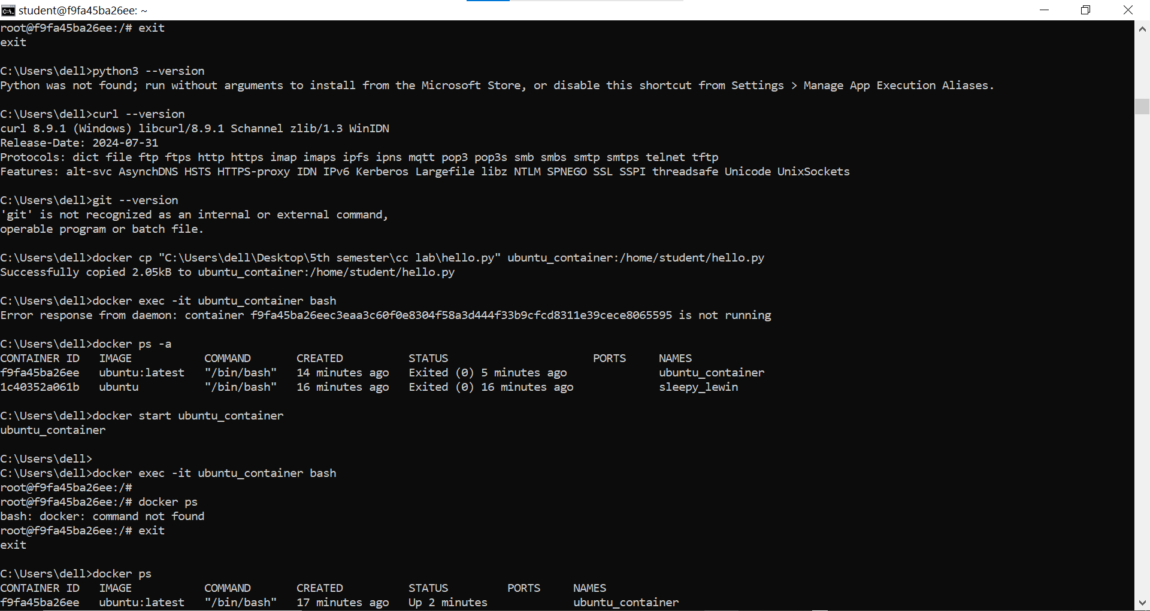

* **TASK 3: BUILDING DOCKER IMAGE**

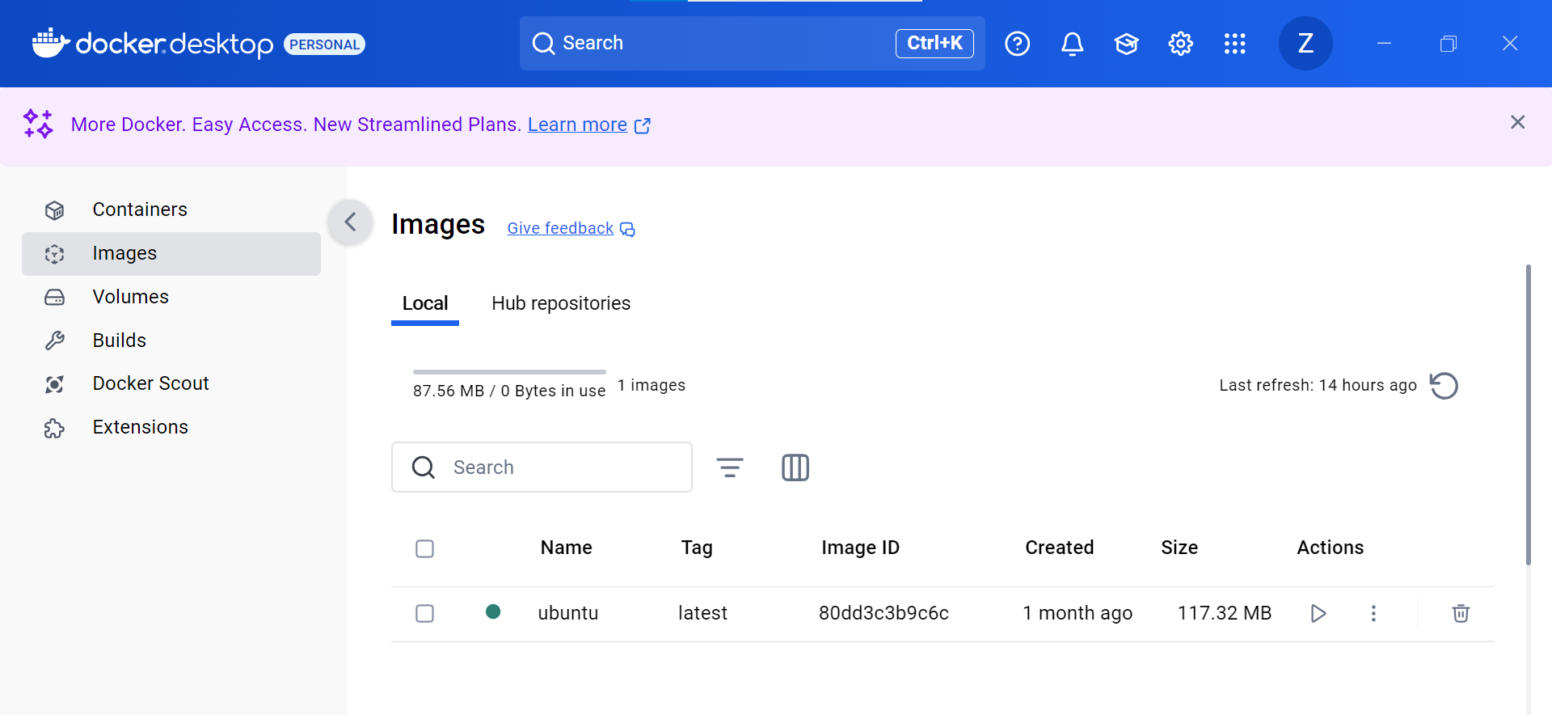

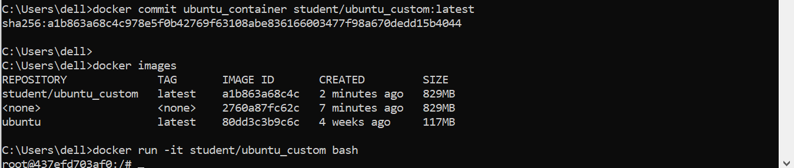

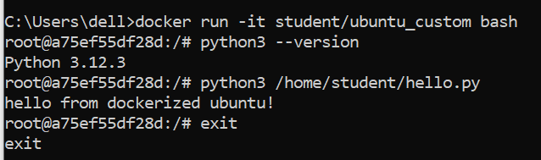

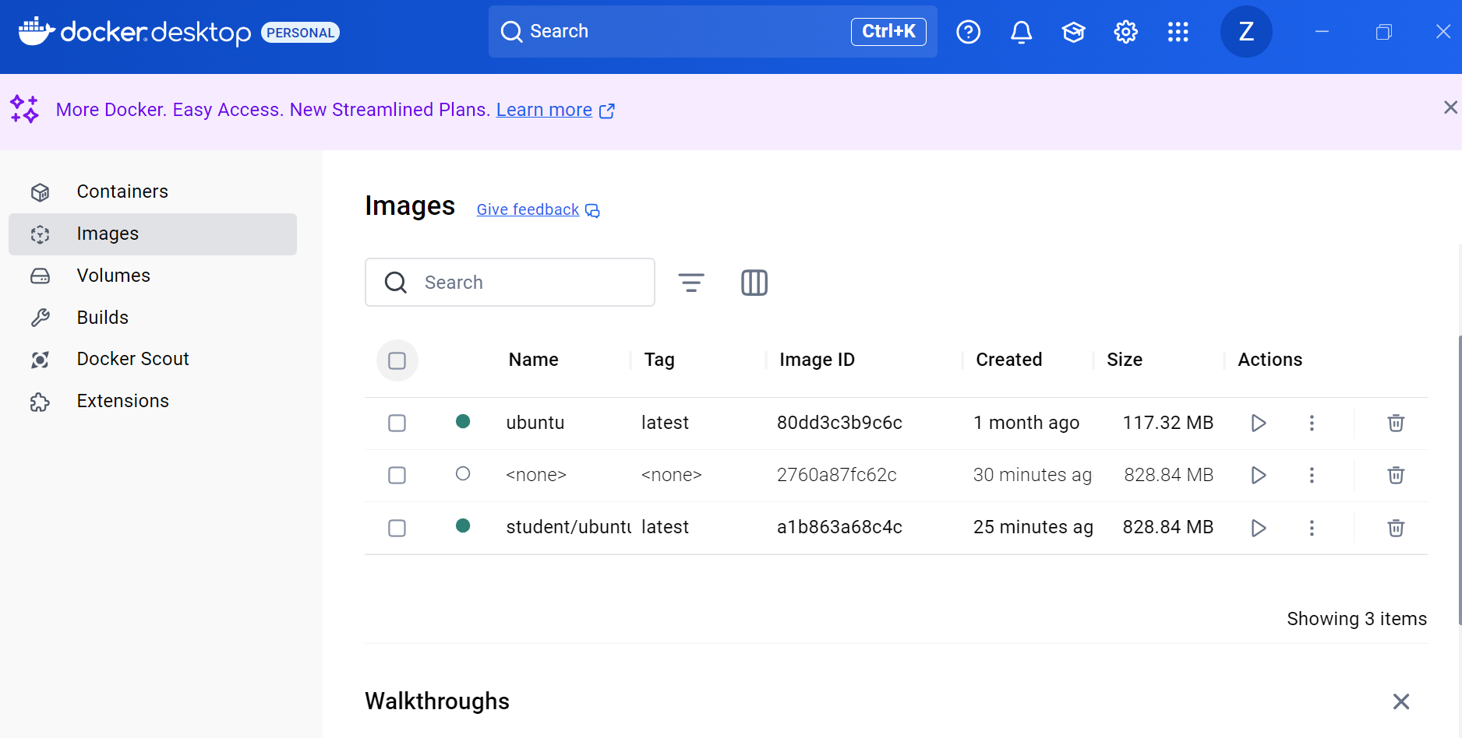

* **TASK 4: RUNNING PYTHON APPLICATION**

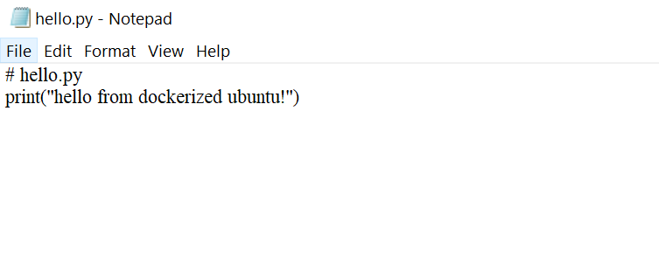

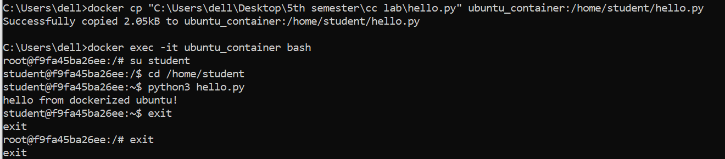

* **TASK 5:EXPOSING THE CONTAINER TO THE HOST SYSTEM**

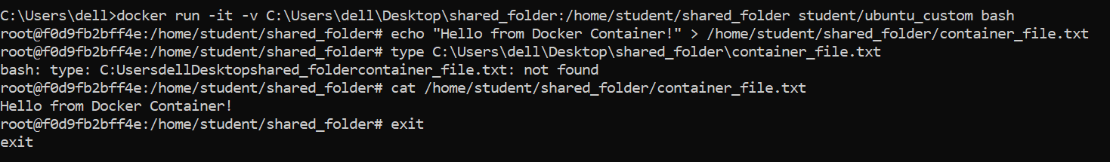



* **TASK 6: CHALLENGES AND SOLUTION**
* The container wasn't running, so we started it using **“docker start.”**
* Then we installed Python, copied **“Python script”** into the container, and ran the script successfully.
* After modifying the container, we created a custom **“Docker image”** (student/ubuntu_custom) using **“docker commit.”**
* To share a directory between the host and the container, we used the **-v** option to bind a host directory to the container.
* We created a file inside the container and initially tried to use Windows commands, but then resolved the issue by using Linux commands like “cat” to view the file inside the container.
* Finally, we verified the file on the host system by navigating to the shared folder and checking the file.

**Conclusion:**

In conclusion, we managed to run a Docker container and made changes like installing Python and adding a script. Then created a custom Docker image from the updated container. By sharing a folder between the host and container, we easily exchanged files. We checked the changes both inside the container. Overall, we learned how to run containers, create custom images, and share files between the host and the container.